For this section just consider the method openDocument in the Vmap class and the use of the parameter url. You should do the following:

Identify all the last defs and first uses of url, concentrating on coupling between the Vmap and Tools classes.

Last Defs

Line 362 - openDocument(URL url) - LD1

The variable url which is passed to the method is not changed through out the openDocument method and therefore is the Last Def of this variable.

First Uses

Line 261 - String fileName = url.toString().replaceFirst("^file:","").replace('/','\\'); - FU1 (WRONG) should be line above

Line 266 - return url.getFile(); - FU2

For this coupling path there is potentially two first uses depending on the OS name and url protocol:
- FU1 is the result of the operating system being windows and the protocol being file.
- Otherwise the first use will be FU2.

Work out the coupling paths that must be followed if the test is to conform to the all-coupling-uses coverage criterion.

Coupling Path | Vmap | Tools
LD1 - FU1 | (osName.substring(0,3).equals("Win")) AND  url.getProtocol().equals("file") | osNameStart.equals("Win") && url.getProtocol().equals("file") : true
LD1 - FU2 | (osName.substring(0,3).equals("Win")) AND  url.getProtocol().equals("file") | osNameStart.equals("Win") && url.getProtocol().equals("file") : false

Develop a test suite for the method that exercises all the coupling paths that you have identified. If for some reason you fail to meet the criterion provide a short explanation why you cannot conform to it in your report.

After the method openDocument has called Tools.urlGetFile it sets the returned value to the variable command.

To develop a test suite for the purposes of coupling we needed to test the two the coupling paths.

We achieved this by

- Building a scaffolding of the Vmap and Tools classes - this scaffolding consisted of just the openDocument and the urlGetFile method.
- Testing both branches resulting from the coupling to Tools

To achieve coupling coverage we need to cover the two branches of coupling paths we identified. To do this we must be in Windows and so had to manually change ‘osName’ (e.g. ‘Windows XP’ and osNameStart = ‘Win’).

We also had to rebuild the getProperty method to return an appropriate string based on the default browser command.

During our testing of the two branches we were unable to test coupling branch (LD1 - FU2). The coupling arises whenever the protocol equals ‘file’ but the

as conditions were impossible because the situation arose where if the protocol is “file” then the first branch of the if statement below is fired.

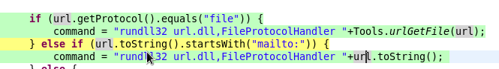

Fig 1.

This would then take us to the tools class. Where the conditions are as follows:

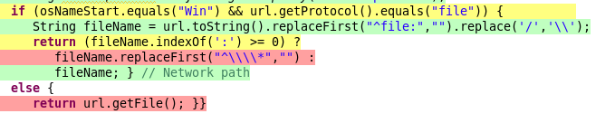
Fig 2.

So the only case where it could take the other branch is if url.getProtocol().equals(“mailto”), but the problem is that if this was the case then we would not be in the Tools class in the first place as in Fig 1 we would have fired the second branch.

SCREENSHOT!

